

*Home of the Timberwolves*

**EVERGREEN MIDDLE SCHOOL**

STUDENT HANDBOOK

2019-2020

|  |  |
| --- | --- |
| **Main Office** | (425) 385-5700 |
| **Main Office Fax #** | (425) 385-5702 |
| **Principal** | Mrs. Michele Waddel |
| **Assistant Principal** | Mrs. Kelly Bell |
| **Assistant Principal** | Mr. Jacob Ellsworth |
| **Registrar Office** | (425) 385-5710 |
| **6th Grade Counselor** | Mrs. Vicki Cornelius |
| **7th Grade Counselor** | Mrs. Cheryl Crosby |
| **8th Grade Counselor** | Mr. William Rosenberger |
| **Attendance Office** | (425) 385-5705 |
| **Health Room/Nurse** | (425) 385-5706 |
| **Mailing Address** | 7621 Beverly Lane, Everett, WA 98203 |
| **Website** | <http://www.everettsd.org/Evergreen> |
| **On Line Gradebook** | <https://lms.everettsd.org> |

**Standard Bell Schedules**

|  |  |  |  |  |  |  |  |  |
| --- | --- | --- | --- | --- | --- | --- | --- | --- |
| **6th GRADE** | | | **7th GRADE** | | | **8th GRADE** | | |
| **First Bell – 7:25 a.m.** | | | **First Bell – 7:25 a.m.** | | | **First Bell – 7:25 a.m.** | | |
| 1st Period | 7:30 – 8:23 |  | 1st Period | 7:30 – 8:23 |  | 1st Period | 7:30 – 8:23 |  |
| 2nd Period | 8:27 – 9:14 |  | 2nd Period | 8:27 – 9:14 |  | 2nd Period | 8:27 – 9:14 |  |
| 3rd Period | 9:18 – 10:05 |  | 3rd Period | 9:18 – 10:05 |  | 3rd Period | 9:18 – 10:05 |  |
| **Lunch** | **10:10 – 10:40** |  | 4th Period | 10:09 – 10:56 |  | 4th Period | 10:09 – 10:56 |  |
| 4th Period | 10:45 – 11:32 |  | **Lunch** | **11:01 – 11:31** |  | 5th Period | 11:00 – 11:47 |  |
| 5th Period | 11:36 – 12:23 |  | 5th Period | 11:36 – 12:23 |  | **Lunch** | **11:52 – 12:22** |  |
| 6th Period | 12:27 – 1:14 |  | 6th Period | 12:27 – 1:14 |  | 6th Period | 12:27 – 1:14 |  |
| 7th Period | 1:18 – 2:05 |  | 7th Period | 1:18 – 2:05 |  | 7th Period | 1:18 – 2:05 |  |
| Departure | 2:12 | 12:57 | Departure | 2:12 | 12:57 | Departure | 2:12 | 12:57 |

***Modified Schedules***

**One hour late start**: School starts @ 8:30 a.m.

**Two hour late start**: School starts @ 9:30 a.m.

**Early Dismissal Schedule**: School out @ 11:30 a.m.

**LIF Fridays Schedule:** School out @ 12:50 p.m.

**General Information**

*School Hours:* School Hours are from 7:30 a.m. – 2:05 p.m. On LIF Fridays school hours are from 7:30-12:50. Evergreen has office staff available to answer telephones from 7:00 a.m. to 4:00 p.m. daily.

* Students should not be on campus before 7:15 a.m. as there is no supervision.
* Students are to leave campus at 2:05 p.m. unless involved *in a supervised activity.*

***Closed Campus*:** Our campus is "closed" between 7:00 – 4:30pm. Once you arrive on campus, you are expected to remain all day unless you have permission from the office to leave. Students need to be signed out with the Attendance Office by a parent or guardian before leaving the campus. **Students not involved in a supervised activity must leave the campus at 2:05 p.m.**

***Dismissal:*** Students are to go directly home when the school bell rings at **2:05 p.m. for dismissal unless they are involved in a supervised school activity for academic support, club or athletics**. **Adults should not enter the building at the end of the school day, this is a safety issue.** School rules apply while students are on their way to and from school. To ensure students arrive home safely, parents must notify the school with a written note when there is a pre-planned change in how the student will be going home. Please contact us prior to 10:00 a.m. to ensure your message reaches your student prior to leaving campus.

***Visitors*:** Parents or guardians are always welcome to visit the school by appointment. Please enter through the Main Entrance by the flag pole. Visitors are required to be buzzed in and must check in at the office and are asked to wear a visitor tag. ***Students******may not bring guests to school****.* Non-students on our campus after being asked to leave will be charged with criminal trespassing on school property.

## Counselors: Counselors will have three years to get to know students. They will be moving from grade to grade with students over the course of their middle school experience. Students may stop by the registrar desk during lunch, passing period, or before or after school to schedule an appointment with their counselor. Here are some good reasons to visit:

* need to report harassment or bullying.
* concerned about a friend showing signs of suicide or self harming.
* want help with scheduling or academic support.
* want a college bound scholarship.
* need mediation with another student.

***School Phones/Family Communication:*** Students need to make calls to guardians from the office. Phone calls home should be for emergency purposes only. Please make arrangements for afterschool plans prior to arrival at school.

***Sales Prohibited:*** Only school authorized items may be sold on campus. Private sales on campus are prohibited.

***Lost and Found:* Please be sure to put your name on your property.** All unclaimed articles should be brought to the office. Found items are placed in a box in the Commons. All items that go unclaimed for a month or more will be donated.

***Timberwolf Cafeteria*:** All students must memorize their student identification number located on their student schedule. They will need it to get their lunch. Lunches may be prepaid by using cash or check payable to Evergreen Middle School. You may also pay for lunches online by debit or credit card. **Students may receive a Free or Reduced cost lunch by filling out the appropriate forms.**

***Health Room*:** If you are not feeling well or injured report to the health room located in the main office. If leaving a classroom, you must have teacher permission and a hall pass. **Do not call your parent from a classroom or a cell phone. Health room assistants or nurses will call your guardian.** *If your temperature is 100 degrees or higher, or if you are injured and unable to attend class, you will be required to go home*. Only a parent/guardian, or people listed as emergency contacts, will be allowed to pick you up. Your parent/guardian will always be called first. Any medication taken during school hours, must be taken in the health room with guardian permission and with the proper forms required to take the medication at school.

***Bike to School Transportation:*** Students may ride their bicycles to and from school; approved safety helmets are required at all times. All students who ride their bikes to school are to follow [EPS Policy 3241](http://docushare.everett.k12.wa.us/docushare/dsweb/View/Collection-197).

***Items Not Allowed At School***: The following items should not be brought to school: trading cards, pets, chains, lighters, electronic games, toys, gum, hats, roller blades, shoes with rollers, skateboards, scooters, basketballs, footballs or any other sporting equipment or large amounts of money. Failure to leave these items at home or in student’s backpack may result in their loss or confiscation. **The school will not be responsible for confiscated items that are lost or damaged**. Refer to [EPS Policy 3240](http://docushare.everett.k12.wa.us/docushare/dsweb/View/Collection-197).

**Attendance**

***BECCA Bill (RCW 28.A.225):* Guidelines for Enforcement:**

After five absences, the parent/guardian will be contacted and the Evergreen Attendance policy will be outlined.

After ten absences, the school will request a meeting with the parent/guardian and student. At this meeting a contract with the student and parent/guardian will be established outlining school attendance requirements.

If the parent/guardian fails to attend the scheduled meeting, a petition will be filed with the court alleging a violation.

***Reporting an Absence:*** Regular and prompt school attendance is essential for continued student progress and school success. When a student arrives at school after 7:30 a.m. he/she is considered tardy and must check in at the attendance office before going to class. At the secondary level, a student’s attendance will be recorded as a period absence if the student arrives 5 minutes or more late to class or leaves 5 minutes or more early. Our attendance office keeps a record of all student absences and tardies. *A parent/guardian should call the office at 425-385-5705 before 10:00 a.m. on the day their student is absent from school, unless the absence is pre-arranged.* If the parent/guardian is unable to reach us in person, the student must bring a note signed by the parent upon returning to school stating dates missed and reason for the absence. An automated calling system will attempt to contact parents by phone and/or e-mail if contact has not been made by the parent prior to 10:00 a.m. on the day of the student’s absence. **Unexcused absences must be excused within 48 hours of the absence.**

***Prearranged Family Trips:*** Students are discouraged from missing school to take trips during the school year or leaving school prior to the normal closing date. Please notify the office at least three days prior to a family trip using the pre-arranged absence form. The form can be picked up from the attendance secretary or printed from the district website.

***Tardies:*** Students are tardy if they are not in their seat when class starts. The missed learning time will have to be made up in detention during lunchtime or after school the following school day.

***Early Dismissal:*** We **discourage early dismissals** because we believe that each school experience is valuable to a student. However, we do recognize the need for doctor and dental appointments or emergencies that may come up. To pre-arrange an early dismissal, students need to come to the Attendance Office before school with a signed note from their parent/guardian indicating the date and time for early dismissal to receive an early dismissal slip. To dismiss a student early, a parent or guardian must check in with the attendance office in the Commons to request their student and to sign the student out of school. Students will be released only to parent/guardians or to emergency contacts listed on the student's contact list.

***Attendance Notification Letter:*** When students have had two unexcused absences or they are in violation of the BECCA Bill, a letter notifying the parent/ guardian of the violation will be sent home.

***3+ Attendance Meeting:*** After three or more unexcused absences, the student and parent/guardian are invited to a 3+ Meeting to learn about the BECCA Law, the process to address student’s lack of attendance, and hear about interventions or resources to help the student regularly attend school.

***BECCA Petition Filing:*** The RCW Chapter 28.A.225 of the Washington State Compulsory Attendance Law (BECCA Bill) specifies that parents/guardians have the primary responsibility for ensuring the attendance of their children at school. The law further states that students shall be regular and punctual in attendance. The attendance procedures at Evergreen Middle School are designed to assist student and parents/guardians in carrying out this responsibility. Missing school for any reason negatively impacts learning, achievement, and grades.

***Community Truancy Board:*** After a BECCA Petition is filed, the student and parent/guardian have a third intervention opportunity. A community truancy board meeting is designed to investigate the barriers to regular attendance and build a plan to over come those barriers to regular attendance. A community member will be a part of that meeting to help connect the student and family to community resources that might help the student be successful.

***Make-Up Homework:*** If your student will be absent for three (3) or more days you may request homework. **Please allow 24 hours for assignments to be collected and sent to the main office for pick up.** There will be extra time allotted to make up work. Students have the responsibility to find out what was missed while they were gone. Students will be expected to make up all missed assignments, including P.E. Students will need to schedule PE make-ups with their PE teacher. We discourage student absences due to vacation or appointments scheduled during the school day.

***Please refer to*** [***EPS Policy 3122***](http://docushare.everett.k12.wa.us/docushare/dsweb/View/Collection-197) ***for additional information on our district’s attendance guidelines.***

**ACADEMIC SUPPORTS**

***Supply List:*** Each grade level’s supply list is posted on Evergreen Middle School’s website. If the student is not able to afford the supplies, please inquire with the front desk for supply assistance.

***Course Syllabus:*** Each teacher will provide students with a syllabus for the semester. The course syllabus will outline the major content standards, units of study, the teacher’s grading policy, homework policy and best forms of communication. With questions specific to content or individual course or teacher expectations, please reach out directly to the teacher either by phone or email prior to contacting administration.

***Homework:*** Homework is an extension of the work done at school. Its purpose is to apply and reinforce what you are learning. **Homework includes 30 minutes of independent reading per night.** Homework success tips:

* Establish a regular study time.
* Find a quiet place to study.
* Check your agenda for assignments due.
* Check off assignments as completed.
* Place all materials together for return to school.

***Online Gradebook:*** The best way to monitor student progress and academic achievement is through regular online grade checks. This can be accomplished by access your student’s gradebook through the school and district website. <https://www.everettsd.org/Page/4701>

***Report Cards:*** Report cards are issued two times each year; in early February and late June. They will be mailed to your home approximately one week after the conclusion of both semesters. Students who are in courses to earn high school credit should keep these report cards on file, and bring them to their high school transition meetings in the spring of their 8th grade school year.

***1 to 1 Technology Devices:*** Electronic devices are checked out to students. Please review the technology device handbook. **The cost of devices, which are damaged, lost, or stolen, will be** **the student’s responsibility**. We urge you to use the protective case provided to protect the device at all times.

***LAP Para-Educator Support:*** Teachers in English Language Arts and Mathematics are supported by Learning Assistance Program para-educators. These para-educators support students during their general education classes, provide support at lunch and after school for all students.

***Homework Club:*** Monday through Thursday students can access adult tutors, a quiet location to complete work and resources after school in the library. Homework Club is open to any and all students between 2:15-3:15pm. Students must sign in by 2:15pm access this support.

***Friday School:*** Teachers can assign students to Friday School each week. On Fridays between 1:00-3:00pm students can work on missing assignments, get support from LAP para-educators and complete projects for their general education classes. Friday School is an opportunity for students to get additional support in maintaining their grades throughout the semester.

***LIBRARY HOURS: 7:20 a.m. – 3:10p.m.***

* + You can use the Library before school, after school, during lunch, or anytime with a pass from your teacher.
  + You may come with your teacher in a class.
  + You may come with a pass. Please sign in to the notebook and leave your pass.
  + Students use their student ID# to check out books. Make sure to memorize your number or have your card with you when in the library
  + Be considerate of your classmates and return materials on or before due dates.If you have overdue books or two books checked out you must return them before checking out additional materials.

***After School Activity Bus:*** Everyday Monday Through Friday there is *a 3:15pm Activity Bus*. Students who stay after for academic support, Homework Club, Friday School, or After School Cubs can use this transportation to safely get home. There is also *a 4:30pm Activity Bus* for athletics.

***Pack Scholar Awards:*** Each month teachers will be able to nominate students who are making progress in their academics. These students will receive an award for their scholarship and be provided VIP seating at the monthly recognition assembly or community building event.

***Honor Roll Recognition:*** At the end of each semester, students who have a 3.5 or higher GPA will receive an Honor Roll Award at the Honor Roll Breakfast. The breakfast happens during the school day, and it is open to family members who want to attend.

***Celebration of Learning:*** The school community will celebrate the success and learning of our students at the end of their 8th grade school year. The Celebration of Learning traditionally occurs that the Civic Auditorium at Everett High School, and each student will receive a set number of tickets to the event. There are speaches by school administrators, student speakers, presentations to highlight the students experience at Evergreen Middle School, and students get to walk across their stage to receive their certificate.

**BEHAVIOR EXPECTATIONS**

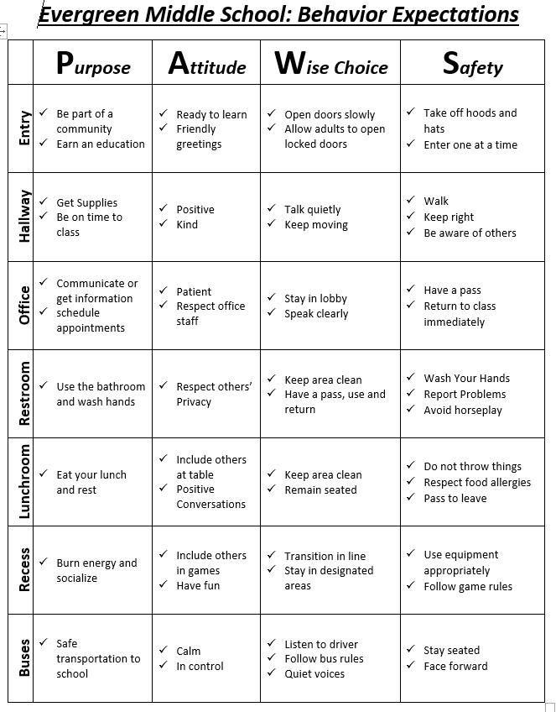***Everett Public School Student Rights and Responsibilities Handbook:*** All students will receive a copy of the EPS Responsibilities and Rights Handbook on the first day of school. Every student and parent/guardian is required to sign the acknowledgement page on the handbook and return it to the school.

***PAWS Expectations:*** Behavior Expectations for students are framed for students using the P.A.W.S. acronym. PAWS stands for purpose, attitude, wise choices and safety. The PAWS Behavior Expectation Matrix for Common Areas is displayed below. This is not an exhaustive list of expectations for student behavior. PAWS Expectations will be taught at the beginning of the year, re-taught as needed and reinforced through various incentive programs throughout the year.

***Non-negotiable/ Non-tolerable Behaviors:***

* + All acts of aggression, harassment, and violence towards other students or staff
  + EMS is a gun-free, weapon-free zone
  + EMS will be free of offensive language.
  + EMS will be free of inappropriate physical displays of affection (i.e. kissing, hugging, hand holding, inappropriate touching, arms around boyfriend/girlfriend.)

***Cell Phone/Electronic Device:*** Cell phones, MP3 players, iPods and e-tablets need to be turned OFF and stored in a backpack before arrival, kept in backpacks during the day between 7:15 a.m. and 2:05 p.m. Cell phones may only be used after the end of the school day in the front office or outside the building. **Any use of a cell phone cameras is prohibited**. **Devices used or ring/vibrate during the day will be confiscated.** Parents will be required to pick up the student’s device in the front office. For further information on appropriate use of personal electronic devices, please refer to EPS Policy 3246.

***Harassment, Intimidation and Bullying:*** It is the policy of Everett School District to maintain a safe, respectful and secure learning environment for all students that is free from harassment, intimidation and bullying (HIB). Please refer to [EPS Policy 3205](http://docushare.everett.k12.wa.us/docushare/dsweb/View/Collection-197) for additional information on our district’s HIB guidelines. Students may not harass, intimidate or bully another student through verbal, nonverbal, or physical conduct on school property (or in reasonable proximity thereto), school transportation, or at school-sponsored activities off school property. Harassment, intimidation or bullying can take many forms, including but not limited to, slurs, rumors, name calling, jokes, innuendoes, demeaning comments, drawings, cartoons, pranks, gestures, hazing, physical attacks, threats or other written, verbal and non-verbal, or physical actions.

***Student Backpacks:*** It is necessary for students to have access to their supplies and backpacks throughout the day.  It is also necessary that our school has a system in place to maximize student safety and instructional time.  As such, students will be asked to:

* Keep their materials and backpacks with them in classes.
* Utilize the square enclosures in each classroom for backpack storage during class time.
* During lunchtime, students will leave their backpack in their before lunch classroom.  At the end of recess, students will pick up their backpacks from their before lunch classroom and proceed to their next class.
* Students will drop their backpack off at their next classroom and then use the restroom during passing periods.  Students will leave their backpacks in the square enclosures in their classroom when using the restroom during class time.

***Dress Code Expectations:*** Student dress will be regulated to preserve a constructive, undisrupted and safe learning environment for all students. Dress which presents a health or safety hazard, damages school property, or which creates a material and substantial disruption of the educational process is prohibited as per [EPS Policy 3224](http://docushare.everett.k12.wa.us/docushare/dsweb/View/Collection-197). Appropriate attire shall exclude any type of dress or manner of grooming which school officials reasonably believe would disrupt or interfere with the school environment, activities, and/or educational process. If an item becomes a distraction from learning, you will be asked to remove it. The following are not permitted:

1. Attire that does not cover undergarments inadequately covers chest/breasts/shoulders, midriff, buttocks or thighs (including holes in pants); displays obscene, sexual, drug or alcohol related messages; or displays gang-related symbolism. Pants, shorts and skirts must be worn at the natural waistline; hemlines should be 2” below the fingertips when arms are in a resting position at the sides. Straps on shirts should be at least 2” wide and cover undergarment straps.
2. Any clothing that would create an atmosphere in which a student, staff member, or another person’s well-being is hindered by undue pressure, behavior, intimidation, overt gesture or threat of violence.
3. Head apparel, other than religious in nature, may not be worn inside the building.

***Substitute and Guest Teacher:*** Students are expected to treat Substitute and Guest Teachers with extra respect.

* Disruptive/ non-cooperative behavior for substitutes will result in a verbal warning.
* If the behavior continues, the student will be sent to the office and a detention is assigned.
* If the student’s behavior still has not been corrected, the student will be removed from the class for the remainder of the period and an administrator will issue a consequence.

***Check the Everett Public School’s Students Rights and Responsibilities Handbook for more information about student expectations, policies and procedures.***

**Behavior Interventions**

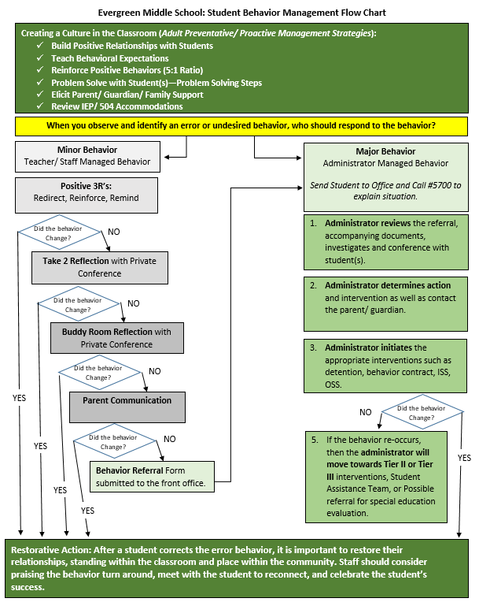***Positive Behavior Intervention Supports:*** Evergreen Middle School is working towards the development of a Positive Behavior Intervention Supports. These supports are designed to hold students accountable, teach desired behaviors and recognize and appreciate positive behavior. There may be additional supports used beyond those listed below. Behaviors are defined as either minor or major. Minor behaviors will be addressed by teachers or staff prior to administrative intervention. Major behaviors will be immediately referred to school administrators.

***Pack Pride Awards:*** Each month teachers will be able to nominate students who are modeling appropriate behaviors. These students will receive an award for their exceptional behavior and be provided VIP seating at the monthly recognition assembly or community building event.

***Three R’s***: Teachers first approach to minor inappropriate student behavior or violation of school rules will be the Three R’s: Redirect, Reinforce, Remind students.

***PAWS Form***: If the behavior continues, the teacher or staff member will ask the student to take a PAWS. This is a reflection sheet designed to help the student identify the problem behavior and problem solve how to improve the behavior.

***Buddy Room:*** If the behavior continues after the student completes the PAWS Form, the teacher or staff member might ask the student to leave the area and go to another location to reflect a second time on the problem behavior.

***Parent Contact:*** If the behavior continues, after the student has been to a Buddy Room, or the behavior becomes a pattern, the teacher or staff member will contact the student’s parent or guardian to seek their support in reinforcing the expected behaviors.

Minor Office Referral: If the behavior continues to occur after the parent has been contacted, the teacher or staff member will refer the student’s behavior to the office by completing an Office Referral form and routed to a building administrator.

***Lunch / After School Detention:*** Students may be assigned detention for a variety of behaviors. Lunch detention is served during the student’s lunch time. After school detention is assigned Monday through Thursday starting at 2:10 to 3:10pm. Students may take an activity bus home after detention, if there is one available. If a student is assigned detention, he/she will report directly to the assigned location. If a student does not attend, they may be reassigned to another day or be subject to greater discipline action. Students should use their time to complete homework or missing assignments.

***Campus Beautification:*** Students may be assigned campus beautification for a variety of behaviors. Campus beautification is assigned Fridays starting at 1:00 to 3:00pm. Students may take an activity bus home after campus, if there is one available. If a student is assigned campus beautification, he/she will report directly to the assigned location. If a student does not attend, they may be reassigned to another day or be subject to greater discipline action.

***Behavior Contracts:*** Students may be assigned a behavior contract for a variety of behaviors. This is a contract between the student and school to monitor and track ongoing behavioral issues. Contracts may have both a reward and consequence attached. Students would be required to share their contract daily with one or several teachers over a set time period. During different times of day, they may be assigned to check in with a staff member to review their contract and reinforce the incentive system.

***Classroom Exclusion***: Students who cause a major disruption to the learning environment may be sent to the office by a teacher or staff member and excluded for the remainder of the class period. Student will be responsible for the assignments or activities assigned during the exclusion.

***In-School Suspension (ISS):*** Students may be assigned ISS for violation of school rules or district codes of conduct. Students will be given a space in the office during the suspension to complete work, a staff member will help the student gather work to complete while in ISS.

***Short-Term Suspension:*** Students may be assigned a short-term suspension for violation of school rules or district codes of conduct. A short-term suspension could last up to 10 days. The front office will gather student work that can be picked up by parent/guardian. Student and parent/guardian could contact their teachers directly.

***HIB Reporting:*** Any student who believes that he or she has been subjected to harassment, intimidation or bullying in the educational environment is encouraged to bring his or her complaint to the immediate attention of a staff member for assistance in resolving the matter. Staff members are expected to intervene and to assist in reporting using the EPS HIB Form. Reports can also be made by calling or texting 1-855-637-2095 or e-mail at [1350@alert1.us](mailto:1350@alert1.us) Students are encouraged to report school-related harassment, intimidation, and bullying of which they have knowledge. False reports, retaliation and reprisal for harassment, intimidation, and bullying also constitute violations of this policy, and discipline will be imposed as appropriate.

Restorative Action: After the student has received corrective action by a teacher, staff member or administrator, it is important for us to repair the relationship, establish a plan to support the student, and praise the student for their actions to get back on track in their education.

***Check the Everett Public School’s Students Rights and Responsibilities Handbook for more information about student expectations, policies and procedures.***